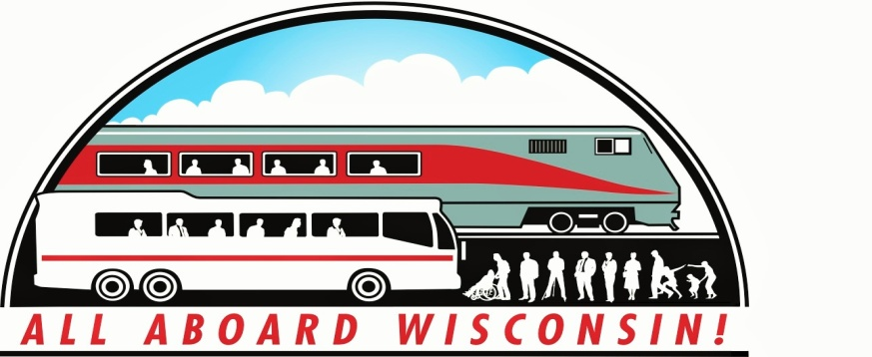

NEWS FROM ALL ABOARD WISCONSIN
February, 2016
Representative Reid Ribble Announces Retirement from Congress.
Retirement Opens Seat on House Transportation and Infrastructure Committee.
Congressman Reid Ribble, a third term Republican who represents northeast Wisconsin’s Eighth District, has announced that he will not run for re-election this fall. Ribble, who is in his 6th year in Congress, had stated early-on in his political career that he did not intend to serve in Congress for more than eight years; did not give any specific reason for deciding to step down after three terms.
For those involved and interested in Wisconsin Transportation, Ribble’s announcement brings with it another large question, as he is currently the only Wisconsin representative on the powerful House Transportation and Infrastructure Committee, which develops and oversees most of the primary policies, regulations and funding proposals for the nation’s transportation industry – including freight and passenger rail. Following the long tenure and seniority on the “T&I” Committee of former 6th District Congressman Tom Petri, who retired before the 2014 election cycle, and who was respected on “both sides of the aisle” for his knowledge and transportation policy expertise; Ribble had built a reputation in his current term as a worthy successor to Petri, and a “rising star” on Congress’ largest committee. He had earned the respect of the powerful T&I Committee Chairman, Pennsylvania Rep Bill Schuster, who included him on the House-Senate Conference Committee that produced the “FAST Act”, the new six year surface transportation legislation that included Amtrak and passenger rail as a part of the overall national surface transportation program for the first time.
As of this writing, there are no announced candidates to replace Ribble as Eighth District Representative. Time will tell if another member of the state’s congressional delegation will indicate an interest in serving on the Transportation and Infrastructure Committee.

Amtrak NEC Service “Soldiers-On” Through East Coast Blizzard.
While highways were reduced to parking lots and airports were jammed with stranded travelers, Amtrak kept its core “Northeast Regional” service up and running throughout the recent east coast blizzard. Locomotive-hauled conventional trainsets kept NEC service up and operational with some delays throughout the storm, although high-speed Acela Express trainsets were held out of service during the peak of the storm and it’s immediate aftermath. While Amtrak was not without it’s own delays and cancellations, compared to other modes of travel during the storm, train travelers could get from city-to-city in the east within a reasonable time. Services outside the Amtrak-owned Northeast Corridor, including Midwest connections on the Capitol Limited and Lakeshore Limited from Chicago, were curtailed or cancelled during the storm while host freight railroads cleared their tracks and dealt with their own weather-related issues.
Surface Transportation Board to Define Amtrak On-Time Performance, Establish Grievance Process:
As reported last month, the Surface Transportation Board (STB) has issued a Notice of Proposed Rulemaking defining what constitutes “on time performance” for passenger rail services. The NPRM responds to Section 213 of the Passenger Rail Investment and Improvement Act of 2008 which established a complaint process which can be invoked if the on-time performance of any intercity passenger train falls below 80% for any two consecutive calendar quarters. Under the proposed rule, the Board may initiate an investigation on its own, or other eligible complainants, including Amtrak, may file a complaint with the Board, requesting a review. Under the NPRM, “on time” would be defined as the train arriving at it’s final terminus no more than 5 minutes after its scheduled arrival time for each 100 miles that the train operated (i.e. 15 minutes for a train that had travelled 300 miles, etc.) , or 30 minutes after its scheduled arrival time, whichever is less. At the same time, the STB issued a proposed policy statement addressing the presentation of issues that might arise in a complaint regarding insufficient on-time performance; and specifically the statutory preference accorded to Amtrak trains over freight trains. More information and access to comments already received is available on the STB site, www.stb.dot.gov.
Our friends and supporters at the Environmental Law and Policy Center have now started a petition drive to urge the STB to take action on it’s proposed rulemaking. Check-out the link below to go to the ELPC web site and sign-on to their petition to the STB. Why not do it now?
> http://elpc.convio.net/site/Advocacy?s_oo=s1ABY40o1VNtgGFaRVQABA&amp;id=1229
> If the text above does not appear as a link or it wraps across multiple lines, then copy and paste it into the address area of your browser.

AAW Officers and Board Gear-up for Upcoming Legislative Activity.
Over the coming few months, All Aboard Wisconsin officers and Board members will be representing the Association in Washington, DC and Madison to ensure Wisconsin’s Passenger Rail voice is heard in the halls of Congress and the State Legislature.
- March 12-16: American Public Transportation Association High Speed and Passenger Rail Committee and Annual Legislative Conference: During this Saturday-Wednesday time period, we’ll discuss the technical aspects of passenger rail development and APTA’s nationwide program to support both the expansion of current service and the on-going development of “true” high speed rail in the US. The technical discussions of the Committee will then lead to an evaluation of what’s going on in Congress with regard to surface transportation policy and funding, followed by meetings with our Congressional representatives and their staffs to seek their support for additional funding and greater program flexibility for Amtrak in particular and passenger rail as well as interconnecting intercity buses and local transit in general. Watch future issues of the Newsletter for reports on our activities.

- Spring Public Transportation Day at the State Capitol: Wednesday, April 20, 2016. Just as in Washington in March, the April focus shifts to Madison and the state legislature. As part of the larger statewide public and specialized transportation community, we’ll begin the day with meetings and presentations on the current state of affairs for transportation funding in the state. Armed with this information and our priorities, this is our day to “knock on doors”, speak with our legislators and their staffs and let them know how important investment in public transportation in all modes – but in particular passenger rail – can and will be to benefit the state going forward.
EMD Rolls-out New Tier IV Compliant Passenger Locomotive.
The new F125 “Spirit” diesel passenger locomotive was officially rolled-out of the Progress Rail facility in Muncie, IN last week. The EPA Tier IV compliant locomotive and 39 of its sisters are destined for the southern California Metrolink commuter rail system, and represent the first new EMD passenger locomotives produced since the 1980’s vintage F59PHI’s. For the other “gearheads” in the audience, the Tier IV emissions compliant Caterpillar C-175-20 prime mover represents the first series production usage of this powerplant in locomotive service. The engine develops 4,700 horsepower in this application, and is designed to be capable of pulling up to 10 cars at 125 MPH. Other technical features include AC traction, extended range blend/dynamic brakes, head-end power regeneration capability and advanced crash energy management. The first units are expected to enter service this year with deliveries continuing through 2017.
AAW Member and Long-time Railroader Jack Fleming Passes-away.
Jack Fleming, retired Milwaukee Road and Amtrak conductor, long-time volunteer at the Riverside and Great Northern tourist railroad in Wisconsin Dells, and a member of All Aboard Wisconsin, passed away on Christmas Day, December 25, 2015 at age 80. Jack hired-out as a Trainman on the Milwaukee Road in 1959 and was later promoted to Conductor. He worked the “Varsity” between Chicago and Madison as well as many other intercity and commuter trains. He was fond of relating that he was conductor on the last Milwaukee Road freight train leaving New Glarus over what is now the “Sugar River” bike trail. All Aboard Wisconsin members will remember Jack as the conductor at the Riverside and Great Northern in Wisconsin Dells following the second Passenger Rail Summit last summer. Our condolences to Jack’s wife of 55 years Sylvia, son and AAW member Tom, and the rest of the Fleming family on his passing.
Thanks to All Who Have Renewed Their AAW Membership for 2016!
We are still accepting membership applications and renewals, so why not ask a friend who’s interested in the development and expansion of passenger rail and coordinated public transportation service to join us? Application forms are available on the AAW website: http://allaboardwisconsin.com.

