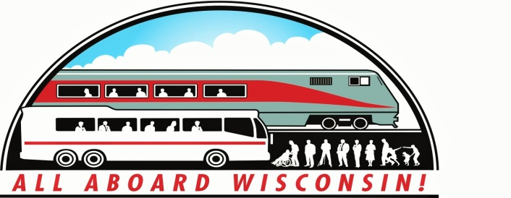
NEWS FROM ALL ABOARD WISCONSIN
SEPTEMBER, 2015
Have You Visited the Website Yet? If you haven’t checked-out http://allaboardwisconsin.com, why not give it a try? Find out the latest news from AAW by checking our Twitter feed under the “News and Blog” button, along with current and back issues of this newsletter. Want to know more about us? The “About Us” tab gives a history of the organization, our mission, and what we’re working-on. There’s even a link to send a message to us! If you or a friend who supports our mission would like to join the AAW team, application forms and dues information are available under the “Support our Work” tab. The website is brand new, so watch for on-going improvements and expansion in the months ahead.

Bi-State Fall Conference Coming-up in 6 Weeks! We’ve been talking about it for several months now, but the time is here to register for the Minnesota/Wisconsin Bi-state Public Transportation Conference, scheduled for October 19-21 in Duluth, MN. This year for the first time, All Aboard Wisconsin is an official sponsor of the conference, and along with that, there is specific passenger rail programming and breakout sessions scheduled for this year’s meeting. In addition, we’ll be joined by our friends and colleagues from All Aboard Minnesota for this event. Things you won’t want to miss:
- We begin with a “bang” on Monday with the All Aboard Wisconsin Annual Meeting in the historic Duluth Union Depot; site of the Lake Superior Railroad Museum.
- Just after the Annual Meeting, we’ll hold a joint session with All Aboard Minnesota to discuss passenger rail developments in both states; with special guest speaker Ed Ellis, Chairman and President of Iowa Pacific Holdings, talking about his company’s array of passenger rail services; including the recently inaugurated “Hoosier” in Indiana, the forthcoming service between Oklahoma City and Tulsa, and his ideas and plans for the future of privately-operated passenger rail service.
- Tuesday special session with Minnesota and Wisconsin Department of Transportation Passenger Rail planners with “the latest” on topics such as the “Second Train Study” –adding another daily Chicago-Twin Cities run opposite the Empire Builder; a Wisconsin Environmental study leading to possible increases in “Hiawatha” service between Chicago and Milwaukee, the Minnesota “Northern Lights Express” or NLX, service from the Twin Cities to Superior and Duluth; the recently announced Federal Railroad Administration Midwest Regional Passenger Rail Study, and several others.
- Also, tour the new intermodal transportation facility – including passenger rail, now under construction in Duluth, which will serve local and intercity buses as well as the Northern Lights Express passenger rail service.
- REGISTER NOW!! Just “control/click” on this link: 2015 MN/WISC Public Transportation Conference & Expo to go to the conference registration page.

Deluxe Rail Travel to the Fall Conference: The private car “Caritas” is filling-up quickly for the rail excursion to the Fall Conference. There are still a few spaces left for the trip, leaving Chicago, Milwaukee, Columbus (Madison) and points north for St. Paul on Sunday, October 18 and returning on Thursday, October 22. The “Caritas” will be attached to the “Empire Builder” in both cases; double-bunk rooms and meal service are provided. To reserve your space, contact AAW Vice-President Nona Hill at 608-467-7835.

“Hoosier State” Service, operated by Iowa Pacific Holdings, Off and Running. Iowa Pacific Holdings took-over operation of the state-sponsored “Hoosier State” service between Indianapolis and Chicago on August 1st. This is the first instance of a private operator taking-over service formerly operated by Amtrak. The “Hoosier State” is being closely watched on all sides to see if this is indeed a viable alternative to Amtrak-operated passenger rail service, and a harbinger of possible other privately-operated regional services. Control/Click or cut and paste this link: https://www.youtube.com/watch?v=3TszX-xazwk&feature=share to see a recent video taken aboard the train between Lafayette, IN and Chicago.

Amtrak Rolls-Out Upgraded “Guest Rewards” Program: If you haven’t seen it yet, Amtrak has announced sweeping improvements to its “Guest Rewards” program for regular customers. Here is a link to Control/click or cut and paste to learn more! http://www.travelpulse.com/news/car-rental-and-rail/amtrak-upgrading-rewards-program-for-2016.html.

Wisconsin and Talgo Reach Agreement on Lawsuit: The state of Wisconsin and Spanish rail equipment manufacturer Talgo have reportedly reached agreement on the breach of contract lawsuit filed by the manufacturer against the state after the two Talgo trainsets previously ordered by the state were rejected after the proposed Madison extension of the Hiawatha service was cancelled by the Walker Administration shortly after taking office. Another link, http://www.jsonline.com/news/wisconsin/talgo-to-keep-trains-get-10-million-more-in-settlement-b99560687z1-322348321.html will take you to a Journal-Sentinel article with all of the explanation.

Amtrak to Pull Station Agent from Winona, MN: Portions of western Wisconsin as well as south-east Minnesota may see a lower level of customer service at the Winona, MN station if Amtrak follows through with it’s plans to remove a full-time agent from the station there. In what’s cited as an economy measure, Amtrak plans to eliminate the agent at Winona, citing the fact that fewer travelers purchase tickets at the station; instead purchasing their fares on-line. Amtrak also points-out that the La Crosse, WI station, about 30 miles south, will continue to be staffed by a full-time agent. The Mayor of Winona is mounting a campaign to convince Amtrak to retain the full-time agent. A newspaper article -http://www.winonapost.com/Article/ArticleID/45521/Amtrak-to-leave-Winona-unmanned gives additional information on the subject; and contact information for those who may wish to make their feelings on the subject known.

Central European Trains Offer Variety: On a recent trip to Central Europe I had the opportunity to travel by rail from Vienna to Budapest on the Austrian State Railways “Rail Jet” service. The equipment, produced by Siemens, is a locomotive-hauled train operated in push-pull mode much like US commuter trains, and propulsion is all electric. Coach, First Class and Business Class service is provided, with business class being the most luxurious. Trains include a dining car as well as at-seat service with a food cart. The ride was smooth and quiet, particularly in Austria, where roadbed maintenance was decidedly better than in Hungary, where there was noticeably more roughness to the ride. The “Rail Jet” name is a bit of a misnomer, leading to the assumption that speeds are similar to the German ICE or French TGV. The highest speed I saw displayed on the monitors in our car was 140 KPH, or about 90 MPH.

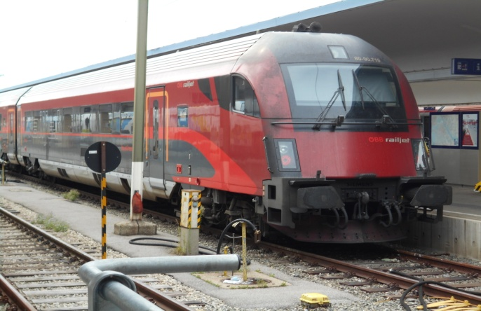

OBB “Rail Jet” at Vienna West Banhof.

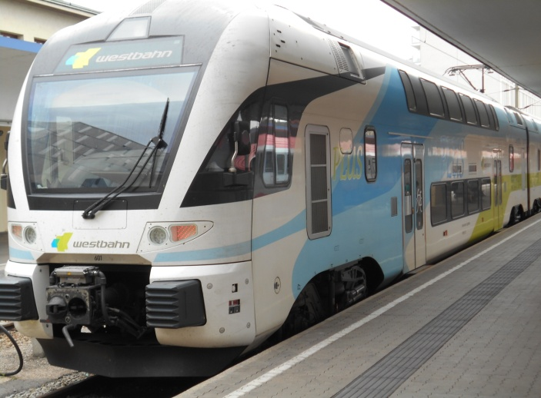

“WestBahn” Regional double deck MU in Vienna.

Hungarian Local Trains still operate to small communities across the country. Here is an “all stops” local arriving in the town of Kiskoros, about 100 KM south-east of Budapest, on its 3 times daily run to the capital city. The 1950’s Soviet era electric locomotive, pulling non-air-conditioned cars of the same vintage, still provides reliable service to rural communities such as this. The town of about 15,000 has a small yard and a diesel switch engine for local work.

